So now that we know how to transform an object, but this cube alone can really only get us so far.We need to know how to add more objects into a scene. So to add any object to the 3D viewport, simply hold **shift** and then press **A** to bring up the add menu as shown below

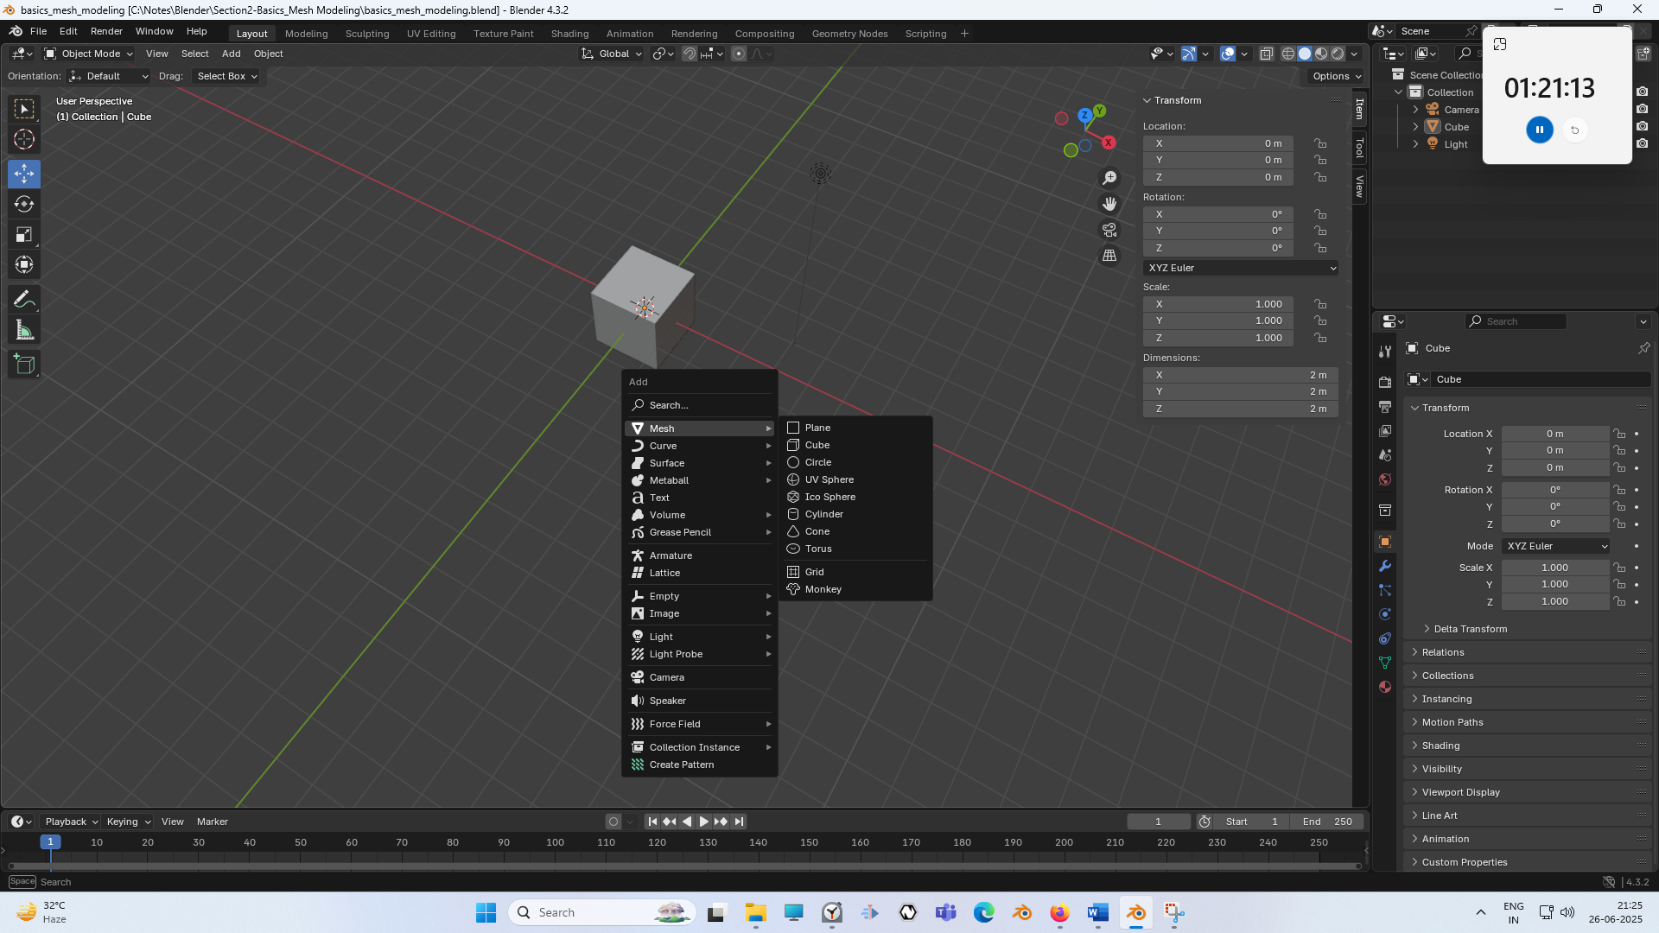

Now you can see in menu Blender gives you this whole list of different types of objects that you can add to your scene. But for now, we are only going to be concerned with this first type here, which is mesh menu. Now if you go to mesh and then a submenu will be opened From there, this whole list gives you the types of mesh primitives that you can add.

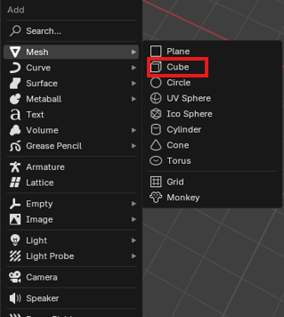

Now as marked above Our default scene always starts with a cube. Any mesh that you add to a scene from this menu is called a **mesh primitive**. They are mesh objects that just have a basic shape, such as a cube, a sphere, a cone, a cylinder. And so on.as shown below

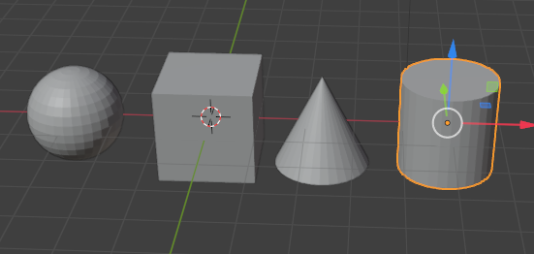

Now these are going to serve as the starting points for modeling more complex shapes.

The ad menu can also be accessed by going to the top toolbar of the 3D viewport as marked below here where it says Add.

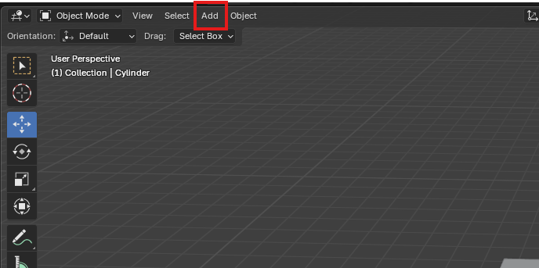

Now here you see the same menu which you see when you press **Shift +A** as shown below



Now when you add a new mash into the scene. You will get this ad menu down at the bottom left hand corner as marked below

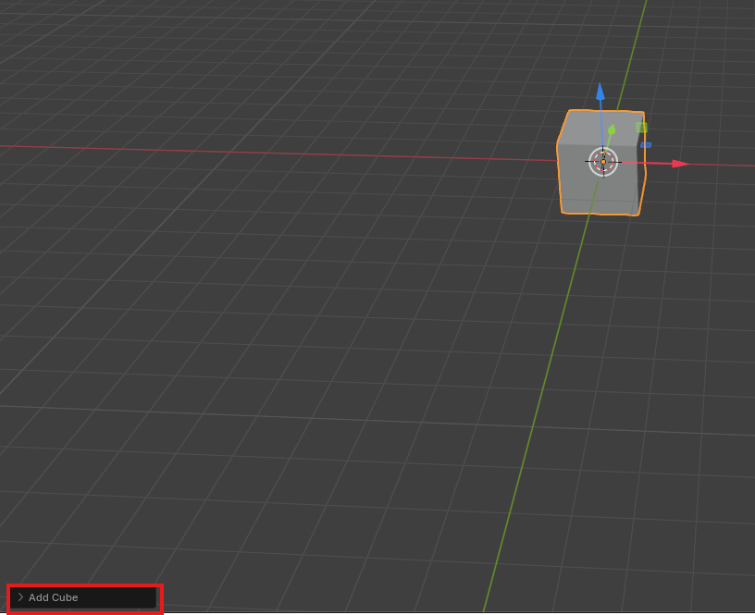

Click to expand it and you'll see there's some initialization options here for the primitive you've just added as marked below

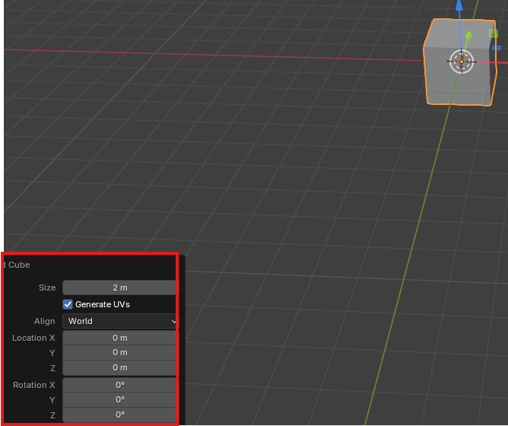

For our example Let remove the cube and add a cylinder

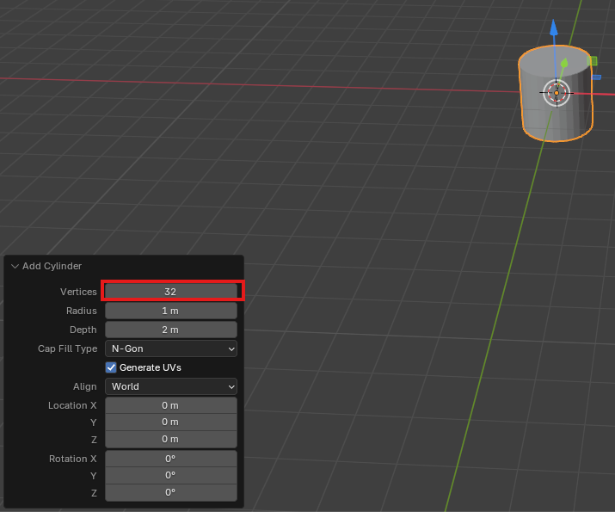

For this cylinder you can choose how many sides it has that make up this circle around the top

**Discovery:-**

It is visible only when your object is just added and selected by default and if you deselect it and select it again then it will not be visible

So setting this vertices value as marked above down to six for example, will turn this into a hexagon with six sides.as shown below

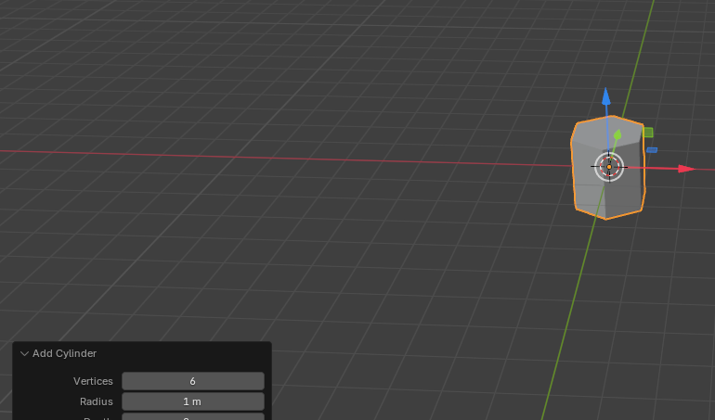

For uv sphere you will see the similar type of initial options as shown below

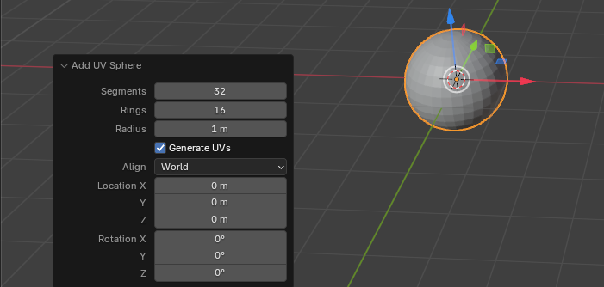

And you can use the sliders here to control how many segments(more like longitudes) and rings(more like latitudes) are in your sphere, which is a great way to control the resolution(who knows).So you can play around with these initialization settings and you can get kind of interesting shapes just from these alone. Like you get by reducing the rings to 4 as marked below

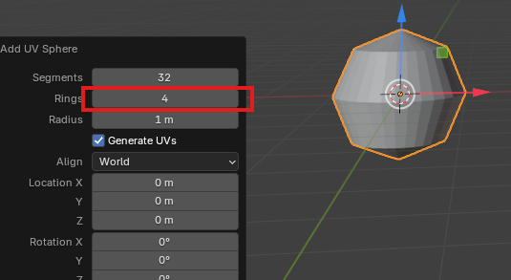

You can see the resultant shape as shown above

Now, the thing to notice about these menus that appear down here is that as soon as we click anywhere off or perform any other operation in Blender, that menu is gone and there is no way to get it back without deleting the object. And you know, readding. here. That's because this initial option menu is only applicable to the last operation(maybe adding the object) you performed.So if you click, that counts as an operation and the menu is gone.

**Discovery:-**

Now whatever setting you do there if you again create a new object of same type then it will be follow the parameters you set in those setting for example if you again create UV sphere again then it will have 4 radius as we set in previous UV Sphere

We add a primitive Monkey that is by getting add menu and then go to mesh and then to Monkey

Now we get the monkey mesh object as shown below

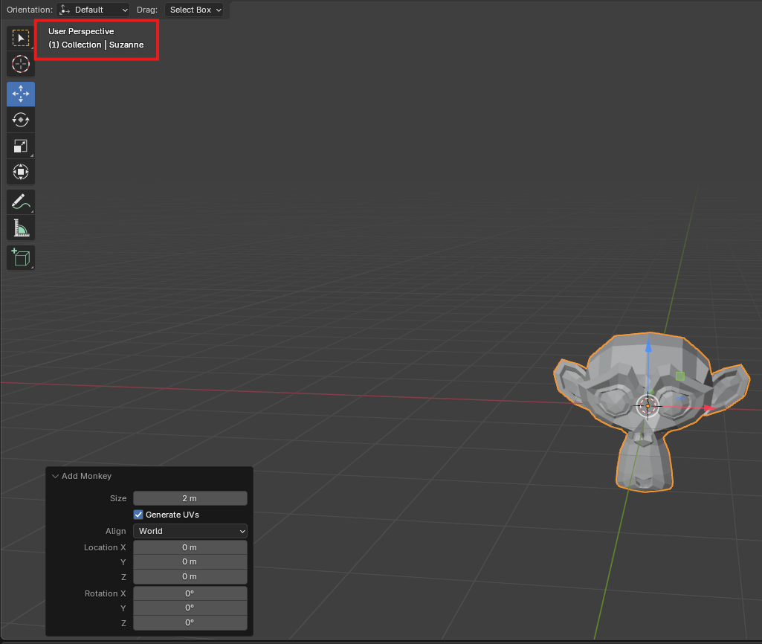

Now, this is Suzanne, as you can see, in the top left corner here as marked above

3:40

And teacher believe the purpose of this being a primitive is for testing materials.

__________________________________________________________________________________

**Discovery:-**

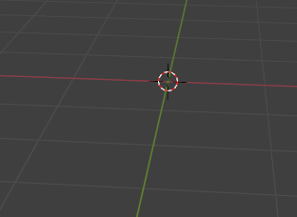

Now the circular thing you see here is maybe called 3d cursor and if you whenever add mesh object then it will be presented here automatically where the 3d cursor is.

You know, this ship has a lot of interesting sort of curves and planes, and it can very quickly show you how a material will appear on a variety of shapes at the same time. But we're going to use her for the purposes of demonstration. So now that we know how to both add and transform primitives where you can use these skills to give Suzanne a hat. Teacher is going to make a party hat for Suzzane. So we are going to add another mesh object by in the viewport pressing shift+A mesh. And then choose cone Now we have our cone as shown below

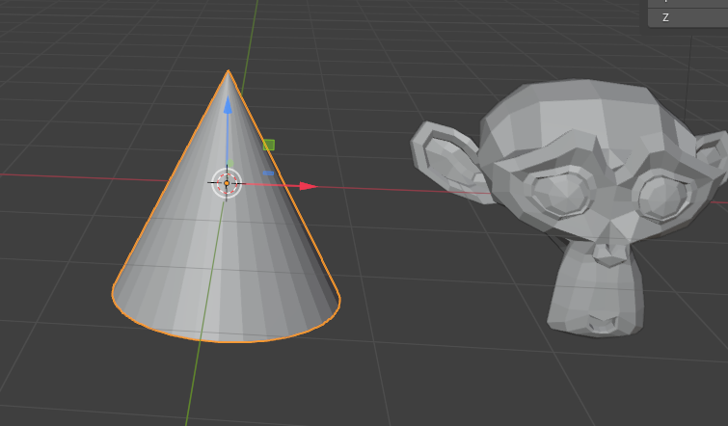

We're going to transform it. So it's in place as a hat.

Press G and z to move it up and now we place it above the Suzzane now our scene will look like below

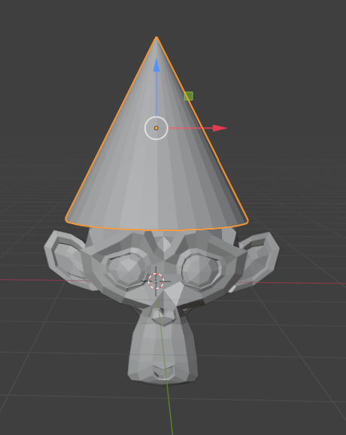

You can press 3 in numpad to look at Suzanne and orthographic side view as shown below

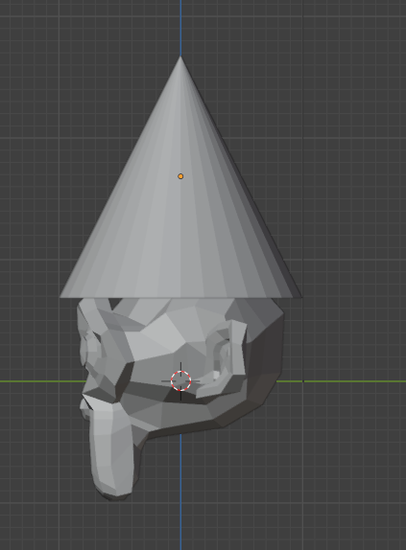

And this will give us a view exactly from the side. And the nice thing about orthographic views is now when I press G, we don't have to press shift + x in this case to lock the x value because we are viewing it exactly from the side. You still can move G along the axis but will it movement be visible the action you are performing depend on how you are viewing the object for example you will not be able to view x movement if you see form the side and also if you are moving something with g and seeing it from the side it will move in y and z plane. We can hit our well rotate along the x axis if we're on, you know, orthographic view and we can hit

Noe in our side view we rotate the object along x axis so that it looks like below

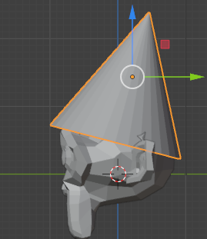

we can hit scale until it's roughly where we want it.(we basically make it look smaller). Now it will look like below

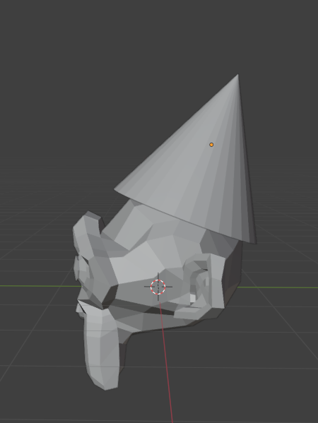

Blender is always going to add new objects wherever this 3D cursor is. 3D cursor is this crosshair icon right here as ,marked below

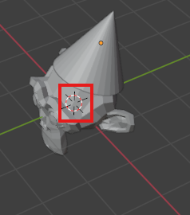

So by default, the 3D cursor is in the center of the world at 000(x,y,z). We can add new objects wherever we want in the scene by moving the 3D cursor. So we can move a 3D cursor by holding **shift** in the viewport and **right clicking** anywhere else in the screen to snap the 3D cursor to a new location( maybe according to the plain you are seeing from and if right click on that object then it get attached to that area of the object ).

Suppose we move the 3d cursor as shown below

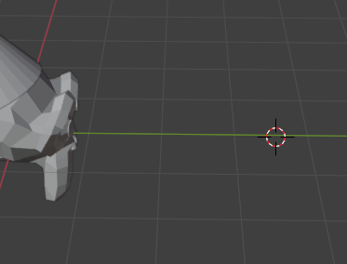

Now if we add a mesh then it will appear here as shown below

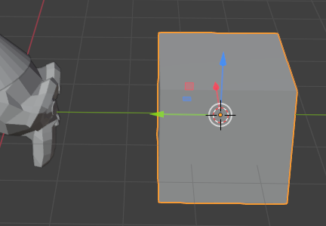

if you've moved the 3D cursor and you want to get it back to the world origin. Exactly. Simply hold shift and press C on the keyboard. Added it over here. if you've moved the 3D cursor and you want to get it back to the world origin. Exactly. Simply hold **shift** and press **C** on the keyboard. This will snap the 3D cursor back to the origin and also reset the camera's zoom so that you'll be focused on the world origin. This will snap the 3D cursor back to the origin and also reset the camera's zoom if you are seeing it from far away or very so that you'll be focused on the world origin.

7:00

This is handy. Sometimes you may accidentally move, you don’t know your view way out and way back like below and you're like, Oh no,I need to get back there(maybe in the centre or of there is any area where there is mesh object (who knows)). Just hold **shift** and press **C** and it'll snap you back to the original.

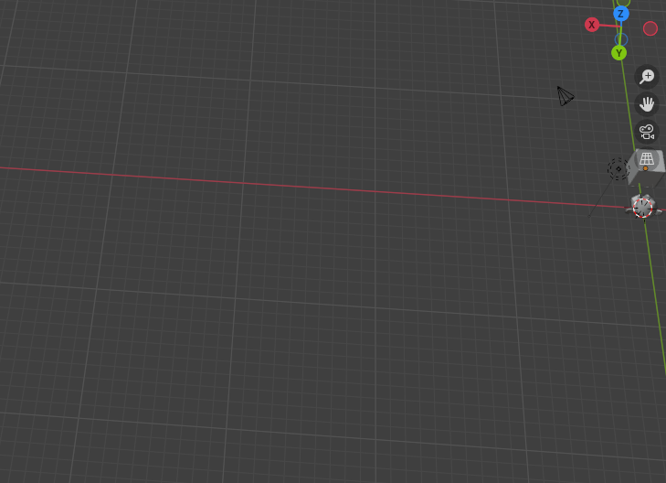

you can easily duplicate any object you've added to the viewport by selecting the object and pressing **shift** and then **d**. And moving it out( you will be moved ) and clicking to confirming the new position.

By this way we duplicate the cube in our viewport

**Before duplicating**

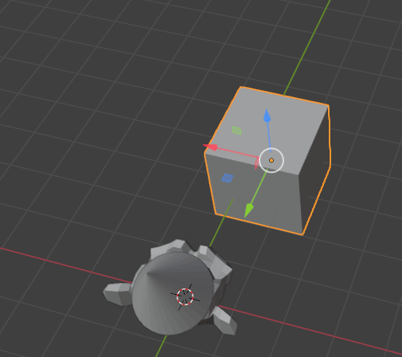

**After duplicating**

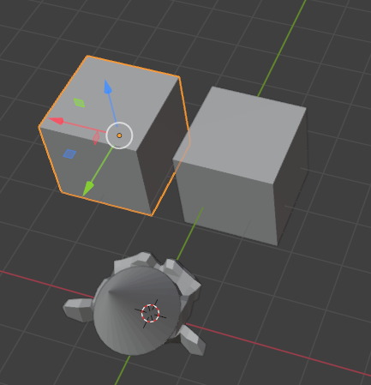

Now you can see that after positioning in above we have duplicated the cube as selected above You can duplicate along a single axis using the same principle of moving along an axis that we just went over with the transforms. So you can select an object, you can press hold shift and press D to duplicate it, and then press Y to move it only along the y axis. Clicking to confirm as always.

Now, once we start having multiple objects in our scene, we're going to want a way to keep track of. And we can do this by renaming these objects.

We can see the name of every object up here in the outliner as marked below

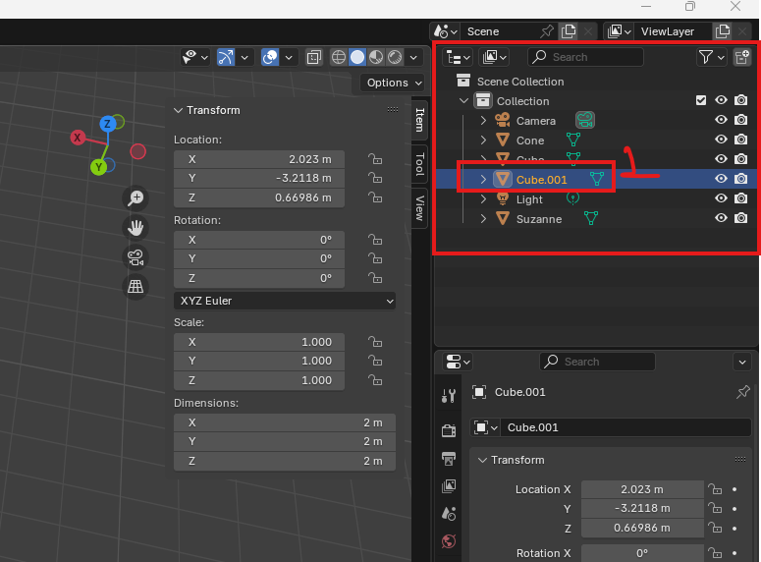

And you'll notice when we start duplicating that blender, adds these suffixes as marked 1 above that is .001. and if we duplicate again the cube then the suffix will say .002 and duplicate again and then suffix you will get .003. this is because no two objects can have the exact same name in Blender. However, if we wanted to name these something other than the default, we can do so by either double clicking this name in the outline or which will bring up an input field. We can type in a name and press enter to confirm it. Or you can do this by clicking the object in the 3D viewport and pressing **f2** on the keyboard which will bring up that same input field as shown below

So we select the cube and then press **f2** to rename and now it will look like below

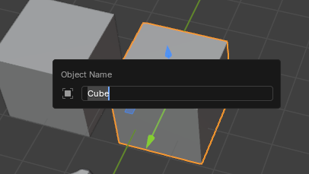

Type the new name for that mesh object that is in this case that is our cube.

To delete an object selected by left clicking and then either hit delete on the keyboard or x which to delete an object selected by left clicking and then either hit delete on the keyboard or press

**x** which will bring up this confirm menu in which there be two option representing delete and another cancel button click on delete button

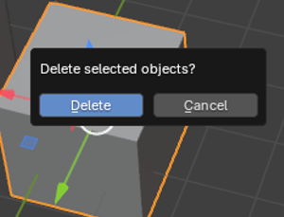

Note that pressing the **backspace** key does not work for this. It is only the delete key.

**X** button is for the deletion after confirmation.

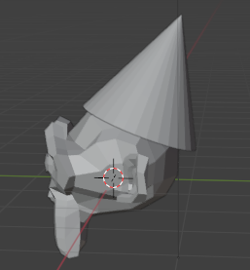

So above is looking pretty good. But we want like a little pom pom on the end of it, right. So how Teacher is going to do that is I'm going to add another object and we are going to add a UV sphere as shown below

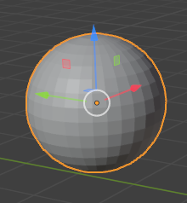

You can make it whatever resolution(maybe that is rings and segment) you want, but those are the default values for a new sphere and a radius of one meter.32 segments, 16 rings and 1 metre radius are the default values We will place it on the peak of our suzzane hat and then scale it down so that it become small Now our suzzane will look like below

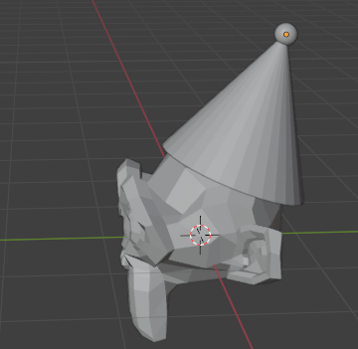

Well, when we click on the hat, you'll notice that it's only highlighting the cone object as shown below

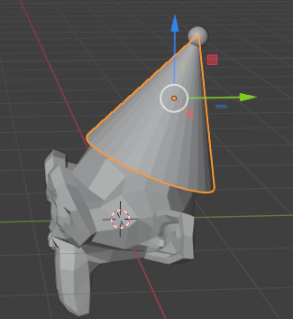

And when I move it, only the cone moves as shown below. That’s sort of a problem.

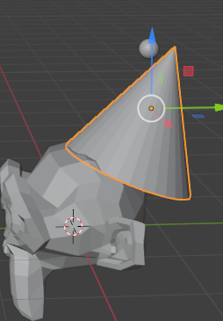

We can click the hat and then **shift** and click on the sphere to multi select. Now when we move it, they move together as shown below

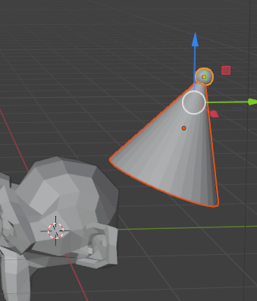

11:36